

🡪

package LabProblem_06;

import java.util.Scanner;

public class Extremes {

public static void main(String[] args) {

Scanner input = new Scanner(System.in);

System.out.println("How many integer you wanna :");

int n = input.nextInt();

int[] arr = new int[n];

for (int i = 0; i < 10; i++) {

arr[i]= input.nextInt();

}

input.close();

int max = arr[0], min = arr[0];

for (int i = 0; i < n; i++) {

if(arr[i]>max)

max = arr[i];

if(arr[i]<min)

arr[i] = min;

}

System.out.println("The minimum value is :"+min);

System.out.println("The maximum value is :"+min);

System.out.println("The sum :"+(min+max));

}

}



🡪

package LabProblem_06;

public class IntegersDivisibleBy3 {

public static void main(String[] args) {

System.out.println("The sum of those integers between 1 and 30 that are divisible by 3.");

int sum=0;

for (int i = 1; i <= 30; i++) {

if(i%3==0)

{

sum+=i;

}

}

System.out.println("The sum :"+sum);

}

}

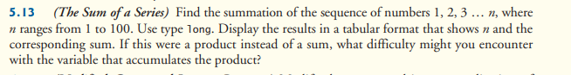

🡪

package LabProblem_06;

public class SumOfSeries {

public static void main(String[] args) {

int sum=0;

System.out.println("The summation of the sequence of numbers 1, 2, 3 … n, where n ranges from 1 to 100. ");

for (int i = 1; i <=100; i++) {

sum+=i;

}

System.out.println("The sum :"+sum);

}

}



🡪

package LabProblem_06;

public class ModifiedCompoundInterestProgram {

public static void main(String[] args) {

int principle = 10000;

int year = 10;

System.out.println("For 5% interest rate :");

System.out.printf("%4s%20s%n","YEAR","Amount");

for (int i = 1; i <= year; i++) {

System.out.printf("%4d%20.2f%n",i,(float)(principle*Math.pow(1+0.05, i)));

}

System.out.println("For 6% interest rate :");

System.out.printf("%4s%20s%n","YEAR","Amount");

for (int i = 1; i <= year; i++) {

System.out.printf("%4d%20.2f%n",i,(float)(principle*Math.pow(1+0.06, i)));

}

System.out.println("For 7% interest rate :");

System.out.printf("%4s%20s%n","YEAR","Amount");

for (int i = 1; i <= year; i++) {

System.out.printf("%4d%20.2f%n",i,(float)(principle*Math.pow(1+0.07, i)));

}

}

}

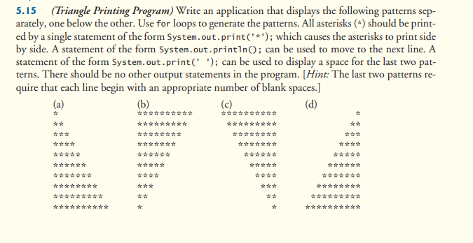

🡪

package TrianglePrintingProgram;

import java.util.Scanner;

public class TrianglePrintingProgram {

public static void main(String[] args) {

Scanner input = new Scanner (System.in);

System.out.println("Enter rows number : ");

int n = input.nextInt();

input.close();

System.out.println("(a)");

for (int i = 1; i <= n; i++) {

for (int j = 1; j <=i; j++) {

System.out.print("*");

}

System.out.println("");

}

System.out.println("(b)");

for (int i = n; i >=1; i--) {

for (int j = 1; j <=i; j++) {

System.out.print("*");

}

System.out.println("");

}

System.out.println("(c)");

for (int i = n; i >=1; i--) {

for (int spa = 1; spa <= n-i; spa++) {

System.out.print(" ");

}

for (int j = 1; j <= i; j++) {

System.out.print("*");

}

System.out.println("");

}

System.out.println("(d)");

for (int i = 1; i <=n; i++) {

for (int spa = 1; spa <= n-i; spa++) {

System.out.print(" ");

}

for (int j = 1; j <=i; j++) {

System.out.print("*");

}

System.out.println("");

}

System.out.printf("%15s","The End");

}

}